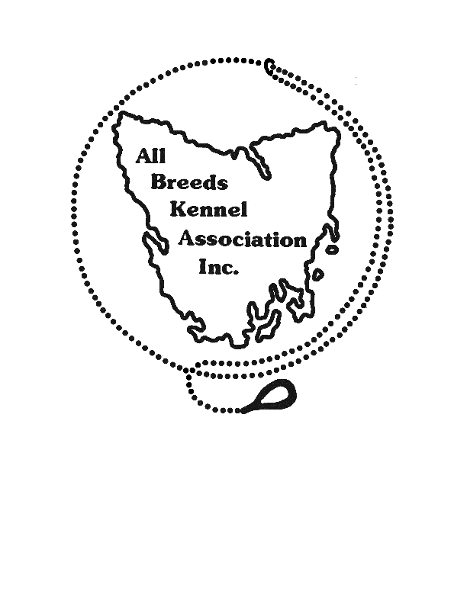 **ALL BREEDS KENNEL ASSOCIATION INC**

**Club Secretary**

**PO Box 134, Launceston**

**Tasmania, 7250**

**Email: abkatas@gmail.com**

1st August 2020

**NOTICE TO ALL MEMBERS:**

**The 2020 Annual General Meeting of the All Breeds Kennel Association Inc will be held on Sunday 13th September 2020**

**at Carrick Hotel, 46 Meander Valley Road, Carrick 7291  
commencing at 11.00AM**

**AGENDA**

1. Members Present
2. Apologies
3. Minutes of the Annual General Meeting 2019
4. Statement of Income and Expenditure
5. Election of Office Bearers and Committee (see Note 1)
6. Appointment of Auditor
7. Special Business (notice required - see Note 2)
8. Close

Note: 1. Nominations for Office Bearers and Committee must be on the form attached and must reach the Returning Officer by close of business on Friday 4th September 2020.

Note: 2. Notices of Motion must be in writing and must reach the Secretary by close of business on Friday 4th September 2020 to allow for publication of the detailed agenda before the meeting date.

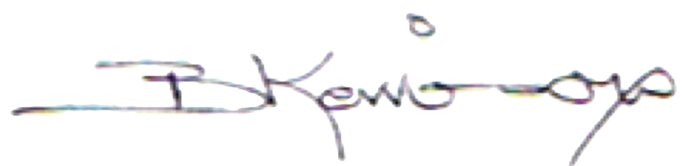

Signed:

Barbara Kerrison

SECRETARY